TREVISO PHOTOGRAPHIC FESTIVAL Third edition
Festival Theme: Light

LAB 77 non profit Aassociation, is pleased to present you the Treviso Photographic Festival
http://www.trevisophotographicfestival.it/

WHEN
From 4 to 21 June 2020

WHERE IS IT
It will take place in the beautiful city of Treviso, 40 km from Venice. The festival takes place in the following areas of the city:

Piazza Borsa - Piazza Crispi- University Square - S. Maria de Battuti square - San Vito square
Cloister of San Francesco - Sagrado church of San Vito Santa Lucia and Sant’ Agostino
Latin neighborhood

PRESS CONFERENCE AND INAUGURATION
The dates will be made official in the coming months
Press conference for journalists only, at the town hall or Palazzo Rinaldi

Inauguration at Palazzo Rinaldi inside two historic rooms, one frescoed.
-Presentation with the authorities, the godmother and the curator
-Performance of dance
- Refreshment for everyone

The godmother of the festival will be Silvia Funes dancer and director of the Fifth dance school of Treviso.
During the festival she will be the curator of some dance performances. Performance venues: Palazzo Rinaldi during the inauguration and some squares during the festival.
https://www.instagram.com/silviafunesfifth/?hl=it

YOUTH PROJECT
We will host some students of the A. Palladio Institute of Treviso. (graphics sector).
In this way, we will give space to young people, one of the objectives of our association.

EXHIBITION OFFICES

SQUARES
The structures will be made of wood and will be distributed in the various squares of the city. On the festival website you can see the map.
The photos will be printed on 5mm Forex material. The photos will be hung on the structures with screws.
The photos will have a frame and in the lower part, the name of the artist, the title of the photo and other information will be shown.
Dimensions: 94x64 cm + 3 cm of white frame on each side. (6 cm in total). If possible, send the photo with this measurement. Print at 200 dpi. I remind you that the photo, if it is not of the dimensions indicated, will be cut. Total size of the print to the public 100x70 cm.

Example of structures
https://www.instagram.com/p/B559pFZItlB/

Structure for special guests

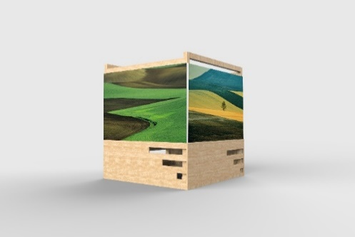
Size :160x 130 cm

CLOISTER OF SAN FRANCESCO

The photos will be hung on the walls of the cloister with chains.
The photos will have a frame and in the lower part, the name of the artist, the title of the photo and other information will be shown.
Photo dimensions: 84x56 cm + 3 cm of white frame on each side. (6 cm in total). If possible, send the photo with this measurement. Print at 200 dpi. I remind you that the photo, if it is not of the dimensions indicated, will be cut. Total size of the print to the public 90x70cm
Material: forex 3 mm

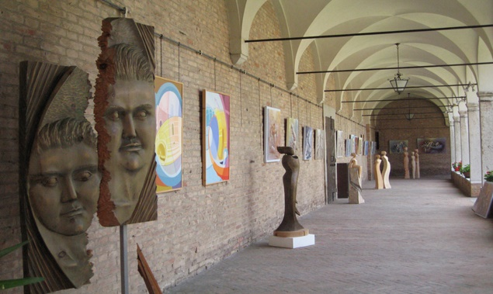

FILE TO SHIP FOR PHOTOS

The photo files must be sent exclusively with we transfer to the following address
lab77associazione@gmail.com

- The photos you want to present for the festival will be viewed on Instagram with the curator.
- Photos must be horizontal
- The photos can be in color or in black and white, to be evaluated with the curator when choosing.

- Send us a photo of your face to the website (the photo must be light).

- Once the festival is over, during the disassembly day, you can collect the photos. Otherwise, the photos will be kept in the LAB77 headquarters or used for projects inside the hospitals. We do not ship to return the photos.

ACTIVITIES OF THE FESTIVAL

Dance performance
Directed by Silvia Funes' Fifth dance school in Treviso.
The performances will take place on some festival squares and on the inaugural day at Palazzo Rinaldi.

Photo Contest
Take photos with your Smartphone in the city of Treviso during the festival from 4 to 21 June. Post them on your Instagram profile by adding #trevisophotographicfestival. The best photo will win a prize.

Guided visit to the Cloister of San Francesco, exhibition venue.
Guided visits to the Cloister are organized (at least 8 people).
Introduction to the history of the Cloister and visit of the photos exhibited at the festival

Workshop / fine art photography walk in Treviso
Going down the streets of Treviso in a laboratory of fine arts / street photography, beginners or professionals, cell phones or DSLRs are welcome. You will be taught how to view and create a scene before it happens. Get ready to increase your photography level on an exceptional path and take some fantastic pictures home.

Social aperitif
Meetings will be held at some venues near the festival to meet the curator and some artists. The aim is to socialize, talk about the festival, meet new people. Our festival is built around social networks but also on the solid roots of our history and our squares.
A way to meet, get to know each other, socialize and exchange ideas.

Reading poems
Photography is a poem that each of us finds within his person, his soul. The moment that button is clicked, we are ready to give life to our poetry. There will be readings by the Friends of the Library Association on some squares interested in the festival.

SIGNING UP

The Undersigned…………………………………………………

declares that he wants to participate in the Treviso Photographic festival 2020. In case of theft or damage to the prints, LAB 77 is not responsible. In relation to the photo festival, I declare to hold harmless the LAB 77 association with registered office in via Fiammoi 102 - 32100 Belluno. C.F. 93056140259 from any third party claims in relation to the content of the photographs presented by me. As for the publication of photos, the legislation governing the publication of other people's images (Law of 22 April 1941 n. 633 Article 96) and the protection of Privacy (law 196 of 2003, replacing 675/96) must be respected. As for links to partner sites or third parties, present in the photos, LAB 77 has no control over these sites and therefore assumes no responsibility for the availability of content, advertising, products or external services available on these sites. It is forbidden to use the images of the works loaned for other purposes without prior written consent from the artists. We have no control over the photos that can be taken by passersby during the festival to your photos, or posted on social media, modified or used for purposes unknown to us. Photos can be collected personally on the day the festival will be dismantled. The photos that remain at LAB77 can be used for exhibitions at some hospitals, or stored in the association's warehouse. The photos will not be sent under any circumstances at the end of the festival. With this registration you are also granted a personal and free registration for the entire year 2020 to the non-profit association LAB77. This registration has no restrictions or expenses

Date and signature
.......................................

Copy and paste and send only the part concerning the completed and signed registration
SEND SIGNED TO THE FOLLOWING EMAIL ADDRESS
lab77associazione@gmail.com

PAYMENT
Payment must be made 7 days after the registration date.
100 euro x photo

We only accept bank transfers.
IF YOU ARE NOT RESIDENT IN THE EURO AREA YOU MUST PAY 10 EURO IN ADDITION FOR THE EXTRA COSTS OF THE BANK.

BANK OF THE BRAND CREDITO COOPERATIVO - SOCIETA COOPERATIVA
IBAN: IT17M0708412000027002812316
BIC CODE: ICRAITRRU40
(If in the insertion phase you should indicate another code, do not worry. The latest numbers may vary because the bank code is indicated, not the branch number).
AMOUNT:………………………………
Beneficiary: LAB 77
Transfer reason: Signing up - Treviso Photographic Festival 2020

Our non-profit association does not have a tax regime, therefore the bank transfer receipt is also valid as a payment receipt.

With best regards
Organizer and curator
Fabio Cavessago

Registered office
Via Fiammoi 102
32100 Belluno - ITALY
CF 93056140259 - Cell 3474704437

e-mail : lab77associazione@gmail.com - photofestivalintv@gmail.com
Instagram: https://www.instagram.com/lab77associazione/?hl=it
Fb lab77
Social e sito del festival
Instagram: https://www.instagram.com/trevisophotographicfestival/?hl=it

